Using Games in Language Teaching
Match a game to a lesson stage

Games as a technique reducing affective filter
Affective factors- what are they? Do we remember in our everyday teaching that they may be crucial in acquiring a foreign language by our students?
The affective domain still needs exploration but quite a few psycholinguists agree that inhibition ( affective factor) may be one of the key obstacles to any learning which requires communication or interaction with other people. Inhibition is caused by anxiety. The higher the level of anxiety, the stronger the inhibiting effect. Affective factors may act as a “mental block” – so called affective filter. If this filter is present then the acquisition of language is prevented.
That is why language teachers should take into consideration these very important mental aspects of learning foreign languages and create relaxed and unstressful atmosphere during a lesson. Language games or game like activities offer teaching possibilities full of fun or even excitement.
Games as a technique enhancing communication
Each real communication act brings with it an element of surprise and anticipation for the speakers. Language games can be used to practise this challenging aspect of interaction in a foreign language offering opportunities for real communication and real speech. They can be a transition stage between structures of language learnt in the classroom and using these forms in real life. They help students to use language imaginatively.
Games in a lesson plan
Games and game-like activities can be applied in each stage of a lesson depending on our aims.
Games as a warming up activity
Students need to switch over to a foreign language at the beginning of a lesson. Game- like activities can satisfy this need. They can not only motivate but also be a tool of revising certain sets of vocabulary or particular structure items. They can also help a teacher to diagnose students’ abilities and show areas that need careful attention.
Verb + noun colocations
Level: elementary
Procedure:
- Each pair, group is given a set of A and B cards, their task is to arrange them into 20 pairs of words comprising a verb and a noun.

Set A
answer | ask
blow | brush
build | climb
cook | catch
draw | drink
drive | eat
fasten | pay
read | ride
sing | smoke
switch on | write

Set B
the phone | a question
your nose | your teeth
a house | a mountain
a meal | a cold
a picture | a cup of tea
a car | a biscuit
a seatbelt | the guitar
a magazine | a horse
a song | a cigar
the television | a postcard

Games at the practice stage
At the practice stage students should use newly presented language in a controlled framework to memorise its form and assimilate its meaning more fully. One of the tools to do the task are games- drillgames, charts, tables, cards, questionnaires or other types teacher may want to invent. No limits for creativity here.

Questionnaire for drilling Present perfect yes/no questions
Level: elementary

Find someone who:
 | question | Name
1 | Have you ever been abroad?
2 | Have you ever travelled on a plane?
3 | Have you ever bought anything online?
4 | Have you ever missed a train/bus?

The face game – practicing vocabulary of feelings and emotions and present simple tense
Elementary/pre intermediate
Procedure / part1:
- Students are divided into groups of four
- players pick labeled cards with faces showing emotions from a pile and answer question: When do you usually feel like this?

Procedure / part2:
- Students are divided into groups of four
- players pick cards with faces showing emotions from a pile and answer question: When do you usually feel like this?

Games at the production stage
The main aim of the production stage is to give students the opportunity to experiment on their own with the language that has been presented and practised by them. Atmosphere is very important at this stage. If it is free and relaxing it encourages using the language, communication becomes freer, more creative, more personally involving, more unpredictable thus more motivating. Games are natural choice for this stage of a lesson.

Connections – creating a mini speech
Procedure:
- students are divided into groups of four
- players pick one card from each pile labeled: people, places, objects, animals
- they create a sentence or even a story using the pictures “Mr Brown is a businessman and travels a lot. He listens to bird singing to make travelling by plane bore pleasant”.

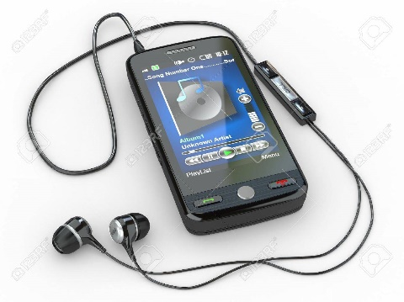

“Mr Brown is a businessman and travels a lot. He listens to birds singing on the internet to make travelling by plane more pleasant”.
bibliography
Explorations in Language Acquisition and Use by Stephen D. Krashen, Heinemann, 2003

